|  |  |  |  |
| --- | --- | --- | --- |
| VIIT Pune (@viit_pune) | Twitter | Bansilal Ramnath Agarwal Charitable Trust's Vishwakarma Institute of Information Technology  Department of  Artificial Intelligence and Data Science | | |
| Student Name: Siddhesh Dilip Khairnar | | | |
| Class: SY | Division: B | | Roll No: 272028 |
| Semester: 4th | | Academic Year: 2022-23 | |
| Subject Name & Code: ADUA22206 & Web Technology | | | |
| Title of Assignment: Assignment No 5: Create HTTP server and create required APIs for user registration of Library Management System form using Node.js | | | |

Aim: Create HTTP server and create required APIs for user registration of Library Management System form using Node.js

Software Requirements: Visual Studio C

Code:

#app.component.html

<mat-toolbar color="primary">

<mat-toolbar-row>

<!-- <span>HOME</span> -->

<span><a href="/">HOME</a></span>

<span class="spacer"></span>

<a mat-button routerLink="/register">Register</a>

<a mat-button routerLink="/login">Login</a>

</mat-toolbar-row>

</mat-toolbar>

<router-outlet></router-outlet>

#app.module.ts

import { NgModule } from '@angular/core';

import { BrowserModule } from '@angular/platform-browser'; import { MatSliderModule } from '@angular/material/slider'; import { AppRoutingModule } from './app-routing.module'; import { MatButtonModule } from '@angular/material/button'; import { MatToolbarModule } from '@angular/material/toolbar'; import { AppComponent } from './app.component';

import { BrowserAnimationsModule } from '@angular/platform-browser/animations';

import { LoginComponentComponent } from './login-component/login- component.component';

import { RegistrationComponentComponent } from './registration-component/registration- component.component';

import { MyComponentComponent } from './my-component/my-component.component'; import { RouterModule, Routes } from '@angular/router';

@NgModule({ declarations: [ AppComponent,

LoginComponentComponent, RegistrationComponentComponent, MyComponentComponent

],

imports: [ BrowserModule, AppRoutingModule,

MatSliderModule, MatButtonModule, MatToolbarModule, RouterModule.forRoot([

{ path: '', redirectTo: '/', pathMatch: 'full' },

{ path: 'register', component: RegistrationComponentComponent },

{ path: 'login', component: LoginComponentComponent },

])

],

providers: [],

bootstrap: [AppComponent]

})

export class AppModule { }

Output:

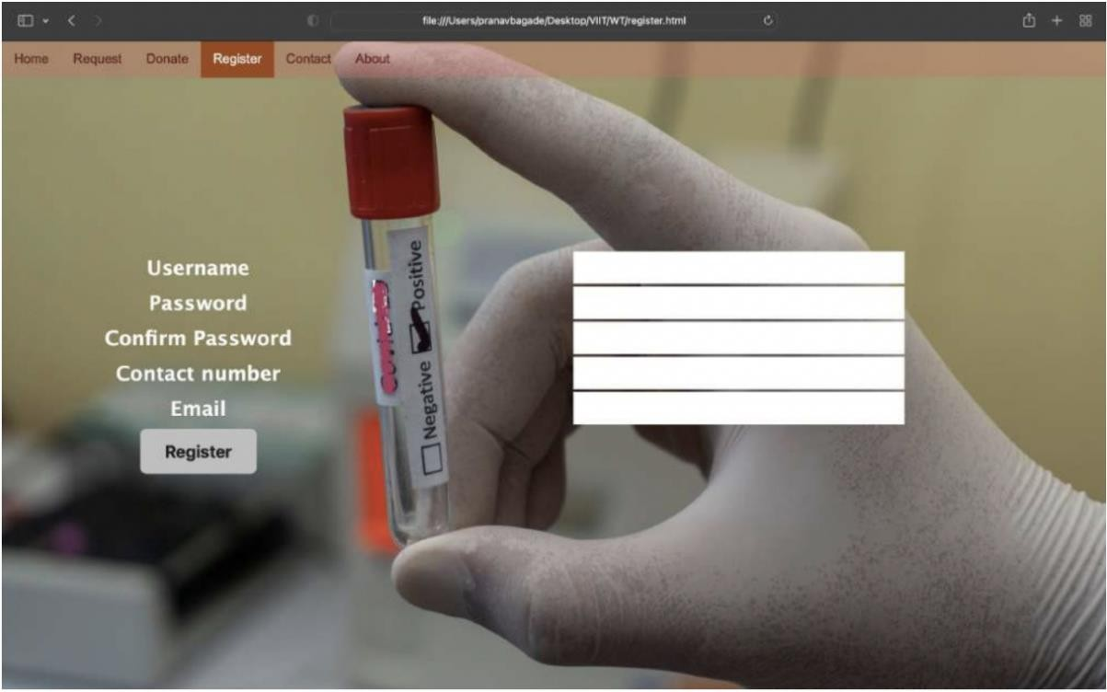

Conclusion: Successfully created HTTP server and create required APIs for user registration of Library Management System form using Node.js